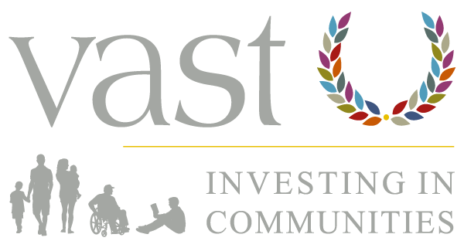

Get Active – Summer 2024 |
#GetActive #StepInTheRightDirection
VCSE Communications Toolkit
This toolkit has been developed by VAST to help voluntary, community, and social enterprise (VCSE) organisations to promote events and to access the support available for people in communities across Stoke-on-Trent, as part of the Get Active summer 2024 campaign.

Contents
Contact Information 1
Introduction and Purpose 2
Audience(s) & Key Messages 2
Local voluntary sector organisations 3
Residents and communities. 3
Resources 4
List of Useful Resources 4
Stoke-on-Trent Community Directory 5
Social Media Content 6
Images 6
Social Media Content Overview 6
General Content 7
Content for Theme One: 0-5 years 8
Content for Theme Two: 65 years plus 9
Content for Theme Three: Obesity 10

Contact Information
For enquiries about this toolkit, please contact Faye Angus, Communications and Content Manager, by email: faye.angus@vast.org.uk.
For information on Get Active please visit www.stoke.gov.uk/getactive
For help and support with the Stoke-on-Trent Community Directory, please contact Monienne Stone, Projects Administrator via monienne.stone@vast.org.uk.

Introduction and Purpose
This VCSE communications toolkit has been developed to compliment Stoke-on-Trent City Council’s ‘Get Active’ campaign, promoting events and support as part of the ‘Get Active’ summer 2024 campaign.
The focus of this toolkit is bringing attention to events, support, and services organisations like yours deliver within the VCSE sector for all members of society. This includes support for harder to reach communities.
For more information on #Get Active #StepInTheRightDirection and the support available from Stoke-on-Trent City Council, please visit: www.stoke.gov.uk/getactive

Audience(s) & Key Messages

Local voluntary sector organisations
  - Promote events and activities organised by VCSE sector as part of ‘GetActive’ campaign, which are aimed at target groups.
  - Promote City-Council events, offers, and activities as part of ‘Get Active’ campaign.
  - The Stoke-on-Trent Community Directory is a one-stop-shop where everyone can find the support and services they need; make sure your organisation and the support you offer is listed.
  - Events, offers and activities are running from July to September 2024.

Residents and communities.
  - ‘Get Active’ campaign aims to improve access to activity between July and September for three key target groups.
0-5 years (and their families)
65 years plus
Those struggling with obesity
  - Provision of targeted events and activity to improve physical and mental health and wellbeing.
  - Activities and events to tackle loneliness and isolation in vulnerable groups.
  - There are lots of community-led activities and events which take place across the city. The ‘Get Active’ campaign will seek to promote events from across the area to ensure they are accessible to all residents.
  - Events and activities will be promoted on social media using the hashtags #GetActive and #StepInTheRightDirection.

Resources

List of Useful Resources
- Website: Stoke-on-Trent Community Directory.
- Website: Directory Things to Do.
- Guide: Getting your organisation on the Directory.
- Website: Stoke-on-Trent City Council – Get Active webpage.
- Social Media Images: Available to download here.
- 0-5 Social Media Content: Click here to download.
- 65+ Social Media Content: Click here to download.
- Obesity Social Media Content: Click here to download.
- General Social Media Content: Click here to download.

Stoke-on-Trent Community Directory
As part of the 'Get Active’ summer campaign, we highly recommend adding your organisation, services, welcoming spaces, activities, events, and any support groups to the Stoke-on-Trent Community Directory. This will help local people to find you and your services easily. If you need help with adding your listing, please email Monienne.stone@vast.org.uk.
The Community Directory is a one-stop-shop for support and services across Stoke-on-Trent and includes lots of information and listings that is split into a number of categories:
- Things to do, including community spaces, cafes, and clubs.
- Health, mental health, and wellbeing support.
- Education, training, and skills.
- Food, money, and energy support – especially useful for cost-of-living support.
- General information and advice including advocacy, legal support, and more.
- Support and advice for carers.
- Safety information and advice including around domestic and sexual violence, safeguarding and more.
- Family support.
- SEN and disability support, and
- Help with housing and home support.
Find out more about the Directory here: https://stokecommunitydirectory.co.uk/about-us/
You can find a step-by-step guide for adding your listing(s) to the directory here.

Social Media Content

Images
Social media images for this toolkit are available to download here: https://vast.org.uk/wp-content/uploads/2024/07/GetActive-Graphics.zip

Please feel free to create your own branded images if you would prefer to use those.

Social Media Content Overview
This content is a general overview of activities, events, offers, support, and where people can get help. There is also tailored content available to download that is shaped around the three themes of Stoke-on-Trent City Council’s ‘Get Active’ campaign:
- 0-5 years - Download here: https://vast.org.uk/wp-content/uploads/2024/07/0-5-GetActive.docx
- 65 years plus - Download here: https://vast.org.uk/wp-content/uploads/2024/07/65-GetActive.docx
- Obesity - Download here: https://vast.org.uk/wp-content/uploads/2024/07/Obesity-GetActive.docx
Please share these posts through your social media channels to help your communities access the activities and events on offer this summer.
This content can also be changed and adapted to meet your needs and to match your organisation’s activities, events, support, services, availability, and/or brand voice.
Where possible and where character count allows, please use the hashtags #GetActive and #StepInTheRightDirection, and tag VAST in your posts. Our social media handles are:
- Facebook: @VASTstaffordshire
- X (formerly Twitter): @VASTstaffs
- LinkedIn: VAST Services (1920)

