Autism Awareness Briefing Sessions 2022 - Follow Up Survey

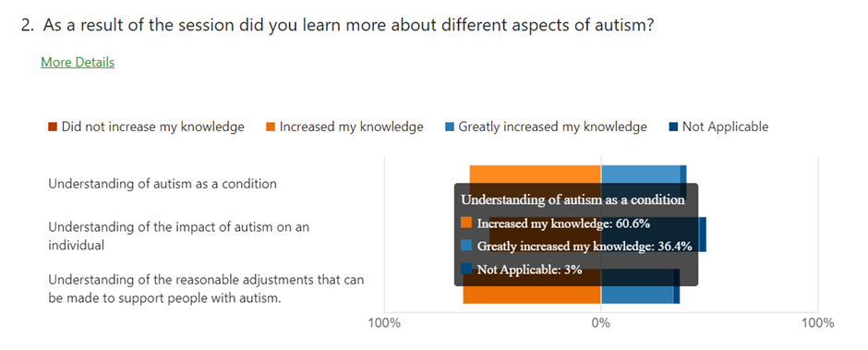

4. Can you describe what you planned to do differently to support people with autism as a result of the session?

|  |
| --- |
| Be mindful in language |
| Be more aware and understanding. |
| To support children to understand their condition and support them to the best of my abilty with the knowledge gained To work with professionals to support children |
| Understanding that autism is not a learning disorder |
| Not be afraid to discuss the condition with the individual and look at how it impacts on them as an individual. |
| keep the routine if you can plan a trip to ensure the person is kept calm |
| My foster child has a friend at school who has Autism and I was hoping to understand to be able to help him. |
| Share with my partner what I learnt as he struggles with the autism traits in our son than I do |
| Having a better understanding of what they might be feeling/going through and to be more patient with them |
| support with referral, more signs and triggers to identify when working with YP and support them with this. |
| I work in palliative care and support Care Homes with planning ahead for end of life. It has raised my awareness to highlight to staff that particularly family members of those who are dying in Care Homes may need greater support and more time to adjust to information giving regarding end of life and decision making. It also made me think about the environment we provide for conversations |
| Ensure all staff have an awareness briefing on a regular basis |
| Be mindful of noise, lights, and sensory input that can overwhelm. I realised that adults would be affected as well - I have always thought of children but obviously its lifelong and so adults will need adjustments too. |
| More aware now to make reasonable adjustments in the work place |
| In the work place with colleagues with autism: 1. make sure routines are not changed without clear explanation of what is changing, when and who is involved. 2. make sure all communication is clear and timely; 3. ask what reasonable adjustments will be helpful In fact looking at the above, that's good practice in any case! |
| Each person responds differently, use varying support mechanisms suitable for the individual needs. |
| To make adjustments in the room / style of counselling in collaboration with the person with autism .. to meet individual needs and not make assumptions. |
| My ability to recognise children exhibiting autistic traits has improved and hopefully I can better support any child we have |
| I planned to establish a Lived Experience Research Group within the Autism Inclusion Team |
| The significant impact that Autism can have on an individual and so myself making more of an effort to empathise with this and change my actions to make people feel more comfortable. |
| Using the understanding of sensory processing and the fact seeing things from someone else point of view is a struggle to adapt how I would explain or talk to someone when they are on my class |
| Find out more about what the individual requires for them to have a positive experience when visiting the surgery, and make reasonable adjustments Don't interrupt and listen |
| Consider how we ensure events that we run and the support we offer is inclusive and consider possible impacts for people with autism |
| Offer more time for someone with autism to process information and respond. |
| The session had lots of very relevant information and I have since enrolled on further learning in this area of personal and professional interest to me. |
| Implementing the communication tips e.g. being clear and specific as non-verbal cues may be missed. |
| 1. Have a better understanding of how people with autism see life, from their point of view. 2. To consider how differently people with autism learn, develop, understand on an individual level. 3. To be able to advise others (especially employers) how the individual with autism would need to be treated in order to gain the maximum potential for both employer and potential employee. |
| The main thing I got out from this was information about autism that I can pass on to others to understand Autism and also to learn more about a person from the person and how to support them in this respect. The language you use is important so to ensure I use language the person is familiar with and understands. |
| To make reasonable adjustments in how I approach assessing an autistic person. |

6. Do you have any comments about this that you would like to share?

|  |
| --- |
| Thank you for the course very informative. |
| Great way to learn, very easy to talk, very relaxed and at a date and time fitting in well with my life. |
| no |
| No |
| It was a brilliant session |
| n/a |
| I would have liked more practical applications of reasonable adjustments. |
| Excellent trainer who delivers from a sound knowledge base Also it is always useful to access free training when part of a small charity with limited funding for training. |
| Regular reminders (like this) help me to remember and check I'm doing what I planned. Its easier when you are working with someone every day, but more difficult if you meet a stranger and you don't know they have an autism diagnosis. |
| Well presented course that added to my knowledge of how to work with people with autism |
| I do not have a child placed at the moment |
| I was surprised to see references to an Autism Rating Scale which is now outdated and consistent use of terms that the majority of autistic people have rejected. |
| I have not yet (to my knowledge) have a learner on my class who has autism so unable to implement changes |
| I have learnt a lot from this course, which encouraged me to want to find out more. I now feel more equipped to make necessary adaptions and share this knowledge. |
| Practical advice given was useful and relatively easy to take on board. |
| I thought that this training was very good and I let my colleagues know about further dates and encouraged them to attend. |
| I'm still working on making these changes |

8. Do you have any comments about this that you would like to share?

|  |
| --- |
| No |
| Thank you for providing this training |
| Talking more with the school and the need to be open with them |
| no |
| No |
| Promoted some discussion of autism in the office. |
| N/A |
| I was surprised that the puzzle piece was used in this course. It was lovely to see so many people attend including groups such as Port Vale FC |
| I thought the training was very good, clear and useful for me in my job for any future learners or for just in everyday life to have a greater understanding in what others may be experiencing. |
| The training sessions was really interesting and gave useful insight into the complexity and variation in the way autism can affect people. |
| The learner I am supporting is very aware of how his autism affects his outlook on life and I can slowly see a shift in at least thinking there is an alternative viewpoint than his own current one. |